**UNIVERSITY OF MANAGEMENT & TECHNOLOGY LAHORE CAMPUS.**

LMS Portal

eiT7HwtR7TYv

**Group Members**

|  |  |  |
| --- | --- | --- |
| **Name** | **ID** | **Email** |
| **Abdul Rehman** | **F2021266081** | **F2021266081@umt.edu.pk** |
| **Shehram Ali** | **F2021266077** | **F2021266077@umt.edu.pk** |
| **Khadija Sikander** | **F2021266053** | **F2021266053@umt.edu.pk** |

**Abstract**

One page overview of your project such as your project idea, why you choose that idea, functionalities, conclusion, and future updating.

Our project is about LMS portal. We chose this idea because as being students ourselves we wanted to work on a system which was familiar to us. We wanted to learn the depth of coding done behind it and how its done. Our system includes 3 main roles of Admin, Teacher and Student. The admin has one of the most important jobs to Add, change or view the courses, students, teachers and their details. He/she can also delete the course, Overall, the Admin holds the power that allows the portal to work smoothly. The Teacher has the necessary functionalities which allows him/her to check all the students enrolled in their courses. They can give quizzes and assignments to the students and further grade them which helps the students to keep track of their GPA. The student has various functions like they can view the details of the courses they are registered in. They can view and attempt the assignments and quizzes uploaded by the teacher and they can further see the grades uploaded by the teachers which is a way easier method than waiting for days to view in person.

It is to conclude that our system performs all the functionalities perfectly. We have been successful in making a system that makes the communication between the Teacher and student and we plan to improve it more professionally in the future which will include the options that has never been used before.

**Introduction:**

A learning management system (LMS) is a software application or web-based technology used to plan, implement and assess a specific learning process. It provides an easier way of communication between a student and teacher. It is used for eLearning practices and, in its most common form, consists of two elements: an Admin that performs the base functionalities and a user interface that is operated by instructors and students.

Basically, the main purpose of LMS is that it allows an instructor with a way to create and deliver content, monitor student participation and assess and grade student’s work. It also provides students with the ability to use interactive features such as Accessing their course material, view assignments, attempt quizzes, upload them and view their gradings.

**Functionalities:**

**Admin**

1.Change details of a student.

2.Change details of teacher.

3.Add a teacher.

4.Add a student.

5.See details of students.

6.See details of teachers.

7.check the details of courses.

8. add a course.

9. delete a course.

**Teacher**

1.Check the list of enrolled students.

2.Give students assignments.

3.Give quiz to students.

4.Go to main menu.

5.Grade the submitted assignments.

6.Grade the submitted quizzes.

**Student**

1.See the details of their registered courses.

2.See assignments.

3.See quizzes.

4.See the grade of assignments.

5.See the grade of quizzes.

6.Logout of LMS.

**Interfaces/screenshots of running state:**

**Attached running screenshots**

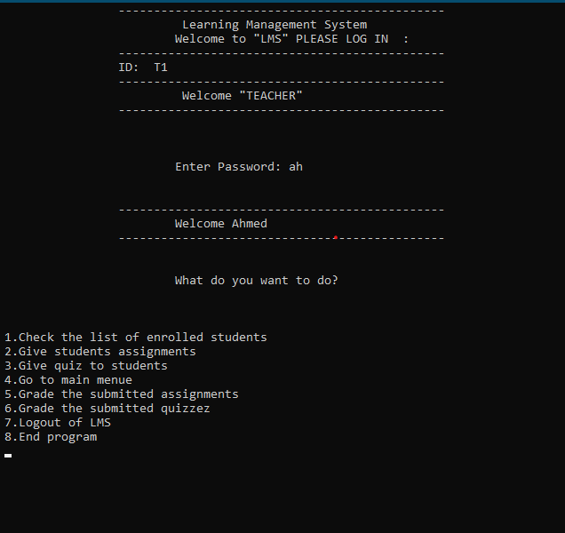 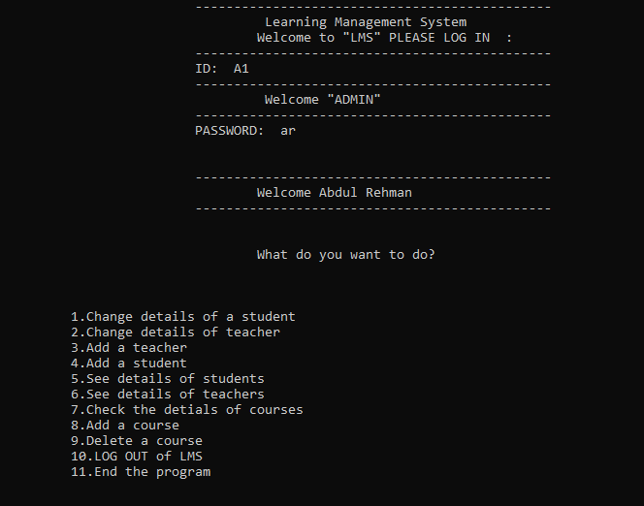

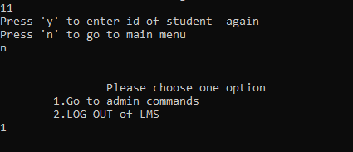

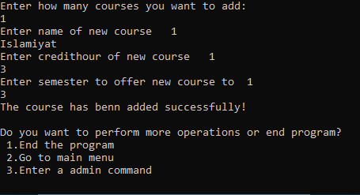

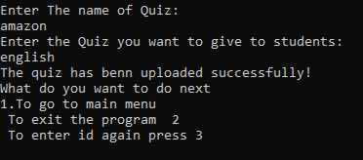

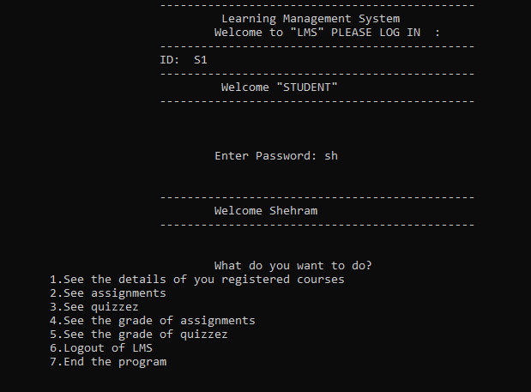 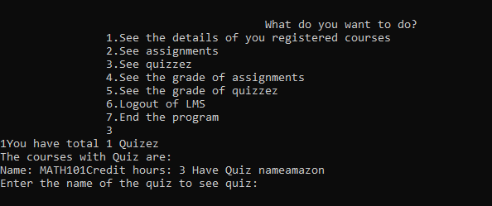



**Conclusion:**

We were successful in performing all the functionalities the Admin and the users perform. It allowed us the insight on how the LMS work and in future we would like to add further video conferencing that makes it easier for students and teacher to teach and study from one platform easily.